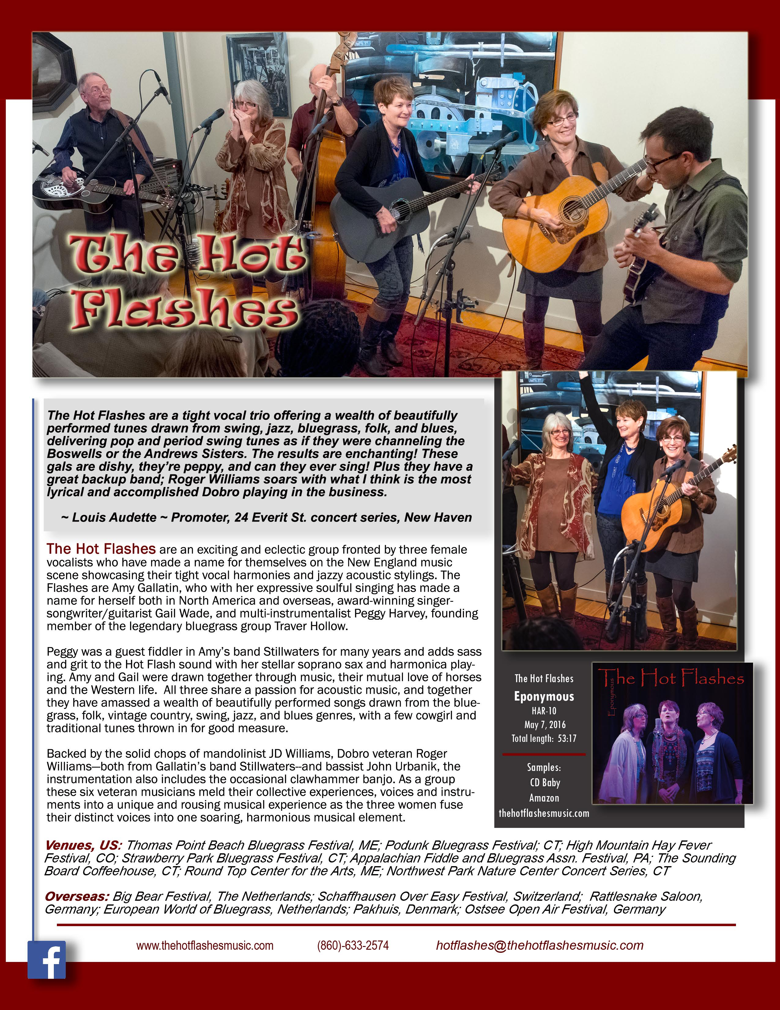

***Venues****,* ***US****: Thomas Point Beach Bluegrass Festival, ME; Podunk Bluegrass Festival; CT; High Mountain Hay Fever Festival, CO; Strawberry Park Bluegrass Festival, CT; Appalachian Fiddle and Bluegrass Assn. Festival, PA; The Sounding Board Coffeehouse, CT; Round Top Center for the Arts, ME; Northwest Park Nature Center Concert Series, CT* ***Overseas****: Big Bear Festival, The Netherlands; Schaffhausen Over Easy Festival, Switzerland; Rattlesnake Saloon, Germany; European World of Bluegrass, Netherlands; Pakhuis, Denmark; Ostsee Open Air Festival, Germany*

*The Hot Flashes are a tight vocal trio offering a wealth of beautifully performed tunes drawn from swing, jazz, bluegrass, folk, and blues, delivering pop and period swing tunes as if they were channeling the Boswells or the Andrews Sisters. The results are enchanting! These gals are dishy, they’re peppy, and can they ever sing! Plus they have a great backup band; Roger Williams soars with what I think is the most lyrical and accomplished Dobro playing in the business.*

*~ Louis Audette ~ Promoter, 24 Everit St. concert series, New Haven*

**The Hot Flashes** are an exciting and eclectic group fronted by three female vocalists who have made a name for themselves on the New England music scene showcasing their tight vocal harmonies and jazzy acoustic stylings. The Flashes are Amy Gallatin, who with her expressive soulful singing has made a name for herself both in North America and overseas, award-winning singer-songwriter/guitarist Gail Wade, and multi-instrumentalist Peggy Harvey, founding member of the legendary bluegrass group Traver Hollow. Peggy was a guest fiddler in Amy’s band Stillwaters for many years and adds sass and grit to the Hot Flash sound with her stellar soprano sax and harmonica playing. Amy and Gail were drawn together through music, their mutual love of horses and the Western life. All three share a passion for acoustic music, and together they have amassed a wealth of beautifully performed songs drawn from the bluegrass, folk, vintage country, swing, jazz, and blues genres, with a few cowgirl and traditional tunes thrown in for good measure.Backed by the solid chops of mandolinist JD Williams, Dobro veteran Roger Williams—both from Gallatin’s band Stillwaters--and bassist John Urbanik, the instrumentation also includes the occasional clawhammer banjo. As a group these six veteran musicians meld their collective experiences, voices and instruments into a unique and rousing musical experience as the three women fuse their distinct voices into one soaring, harmonious musical element.